

**WEB DESIGNING PROJECT**

**FOR**

**TRIBUTE WEBSITE**

**Quarter III (Year 1)**

**Submitted by**

Sarvesh J.A E5221010

In partial fulfilment for the award of the degree of

**BACHELOR OF SCIENCE**

**IN**

**AI AND DA**

**Sri Ramachandra Engineering and Technology**

**Sri Ramachandra Institute of Higher Education and**

**Research, Porur, Chennai – 600116.**

**APRIL, 2022**

**Introduction:**

**As a fresher, the best website you can create is a tribute page of someone who inspires you in your life.**

**The website has been designed entirely using HTML, CSS and Bootstrap. It is designed in such a way that it is accessible on any digital device. The website has all essential components, making it fully responsive.**

**Code:**

**Index.html**

<!DOCTYPE html>

<html>

    <head>

        <link rel="stylesheet" href="C:\Users\91938\Desktop\sarvesh\html\bootstrap-3.4.1-dist\css/bootstrap.min.css">

        <link rel="stylesheet" href="main.css">

        <title>Tribute to Periyar</title>

    </head>

    <body>

        <div class="container-fluid">

            <div class="row">

                <div class="col-sm-12" style="padding: 0 !important;">

                    <section id="header_part">

                        <h1 id="prime_heading"><svg xmlns="http://www.w3.org/2000/svg" viewBox="0 0 576 512"><!--! Font Awesome Pro 6.1.1 by @fontawesome - https://fontawesome.com License - https://fontawesome.com/license (Commercial License) Copyright 2022 Fonticons, Inc. --><path d="M463.1 474.7C465.1 486.7 460.2 498.9 450.2 506C440.3 513.1 427.2 514 416.5 508.3L288.1 439.8L159.8 508.3C149 514 135.9 513.1 126 506C116.1 498.9 111.1 486.7 113.2 474.7L137.8 328.1L33.58 225.9C24.97 217.3 21.91 204.7 25.69 193.1C29.46 181.6 39.43 173.2 51.42 171.5L195 150.3L259.4 17.97C264.7 6.954 275.9-.0391 288.1-.0391C300.4-.0391 311.6 6.954 316.9 17.97L381.2 150.3L524.9 171.5C536.8 173.2 546.8 181.6 550.6 193.1C554.4 204.7 551.3 217.3 542.7 225.9L438.5 328.1L463.1 474.7zM288 376.4L288.1 376.3L399.7 435.9L378.4 309.6L469.2 219.8L343.8 201.4L288.1 86.85L288 87.14V376.4z"/></svg>Tributestars.com</h1>

                        <div id="main_heading">

                            <h1>E.V Ramasamy Periyar</h1>

                        </div>

                        <div id="slider">

<figure><a href="./form.html"><img src="./program_invite.png" alt="Image does not exist" id="invite"></a></figure>

                            <figure><img src="./wp_1.jpeg" alt="Image does not exist"></figure>

                            <figure><img src="./wp_2.jpeg" alt="Image does not exist"></figure>

                            <figure><img src="./wp_3.jpeg" alt="Image does not exist"></figure>

                            <figure><img src="./wp_4.jpeg" alt="Image does not exist"></figure>

                            <figure><img src="./wp_5.jpeg" alt="Image does not exist"></figure>

                            <figure><img src="./wp_6.jpg" alt="Image does not exist"></figure>

                            <figure><img src="./wp_7.jpg" alt="Image does not exist"></figure>

                            <figure><img src="./wp_8.jfif" alt="Image does not exist"></figure>

                        </div>

                        <marquee height:"10px" width:"100%" behavior="" direction="right"><a href="./form.html">

                            On behalf of Periyar's birthday we are conducting a online program on <b>5th May 2022 at 10:00 am</b>. Those who want to participate can register by clicking here.</a></marquee>

                    </section>

                </div>

            </div>

            <div class="row">

                <div class="col-sm-12">

                    <div class="table">

                        <table>

                            <thead>

                                <tr>

                                    <th>Contents</th>

                                </tr>

                            </thead>

                            <tbody>

                                <tr>

                                    <td><a href="#inreo">Who is Periyar?</a></td>

                                </tr>

                                <tr>

                                    <td><a href="#history">History of Periyar</a></td>

                                </tr>

                                <tr>

                                    <td><a href="#kashi">Kashi Pilgrimage Incident</a></td>

                                </tr>

                                <tr>

                                    <td><a href="#srm">Self Respect Movement</a></td>

                                </tr>

                                <tr>

                                    <td><a href="#opp_hindi">Opposition to Hindi</a></td>

                                </tr>

                                <tr>

                                    <td><a href="#president_jp">As President of the Justice Party (1938–1944)</a></td>

                                </tr>

                                <tr>

                                    <td><a href="#women's_rights">Women's Rights</a></td>

                                </tr>

                                <tr>

                                    <td><a href="#more">For more reference</a></td>

                                </tr>

                            </tbody>

                        </table>

                    </div>

                </div>

            </div>

            <div class="row">

                <div class="col-sm-12">

                    <section class="content">

                        <div id="intro">

                            <h3>Who is Periyar?</h3>

                            <p>         E V Ramaswamy, known as Periyar, is Tamil Nadu’s famous social reformer. His father was a rich businessman in Erode,

                                Tamil Nadu.  He grew up in a pious  Vaishnavite family, listening to Hindu scriptures from his childhood. At the

                                young age of 25, he went on a pilgrimage to Kasi to visit the temple of Lord Kasi Viswanath</p>

                        </div>

                        <div id="history">

                            <h3>

                                History of Periyar

                            </h3>

                            <p>         Erode Venkata Ramasamy was born on 17 September 1879 to a Kannada

                                Balija merchant family in Erode, then a part of the Coimbatore

                                district of the Madras Presidency. Ramasamy's father was Venkatappa

                                Nayakar (or Venkata), and his mother was Chinnathyee, Muthammal.

                                He had one elder brother named Krishnaswamy and two sisters named Kannamma

                                and Ponnuthoy. He later came to be known as "Periyar" meaning 'respected

                                one' or 'elder' in the Tamil.</p>

                                <br>

                                <p>     Ramasamy married when he was 19, and had a daughter who lived for only

                                5 months. His first wife, Nagammai, died in 1933. Ramasamy married for

                                a second time in July 1948. His second wife, Maniammai, continued Ramasamy's

                                social work after his death in 1973, and his ideas then were advocated by

                                Dravidar Kazhagam.</p>

                                <br>

                                <p>      In 1929, Ramasamy announced the deletion of his caste title Naicker from his name

                                at the First Provincial Self-Respect Conference of Chengalpattu.

                                He could speak two Dravidian languages: Kannada and Tamil. Ramasamy attended

                                school for five years after which he joined his father's trade at the

                                age of 12. He used to listen to Tamil Vaishnavite gurus who gave discourses

                                in his house enjoying his father's hospitality. At a young age, he began

                                questioning the apparent contradictions in the Hindu mythological stories.

                                As Ramasamy grew, he felt that people used religion only as a mask to deceive

                                innocent people and therefore took it as one of his duties in life to

                                warn people against superstitions and priests.</p>

                        </div>

                        <div id="Kashi">

                            <h3>Kashi Pilgrimage Incident</h3>

                            <p>           In 1904, Ramasamy went on a pilgrimage to Kashi

                                to visit the revered Shiva temple of Kashi

                                Vishwanath. Though regarded as one of the holiest

                                sites of Hinduism, he witnessed immoral activities

                                such as begging, and floating dead bodies.[16] His

                                frustrations extended to functional Hinduism in

                                general when he experienced what he called Brahmanic

                                exploitation.</p>

                                <p>         However, one particular incident in Kasi had a profound

                                    impact on Ramasamy's ideology and future work. At

                                    the worship site there were free meals offered to guests.

                                    To Ramasamy's shock, he was refused meals at choultries,

                                    which exclusively fed Brahmins. Due to extreme hunger,

                                    Ramasamy felt compelled to enter one of the eateries

                                    disguised as a Brahmin with a sacred thread on his bare

                                    chest, but was betrayed by his moustache. The gatekeeper

                                    at the temple concluded that Ramasamy was not a Brahmin,

                                    as Brahmins were not permitted by the Hindu shastras to

                                    have moustaches. He not only prevented Ramasamy's entry

                                    but also pushed him rudely into the street.</p>

                                <p>            As his hunger became intolerable, Ramasamy was forced to

                                    feed on leftovers from the streets. Around this time,

                                    he realised that the eatery which had refused him entry

                                    was built by a wealthy non-Brahmin from South India.

                                    This discriminatory attitude dealt a blow to Ramasamy's

                                    regard for Hinduism, for the events he had witnessed at

                                    Kasi were completely different from the picture of Kasi

                                    he had in mind, as a holy place which welcomed all.[16]

                                    Ramasamy was a theist until his visit to Kasi, after

                                    which his views changed and he became an atheist</p>

                        </div>

                        <div id="srm">

                            <h3>Self Respect Movement</h3>

                            <p>             Ramasamy and his followers campaigned constantly to influence

                                and pressure the government to take measures to remove social

                                inequality (abolish untouchability, manual scavenging system etc.),

                                even while other nationalist forerunners focused on the struggle

                                for political independence. The Self-Respect Movement was described

                                from the beginning as "dedicated to the goal of giving non-Brahmins a

                                sense of pride based on their Dravidian past"</p>

                            <p>             In 1952, the Ramasamy Self-Respect Movement Institution

                                was registered with a list of objectives of the institution from which

                                may be quoted as</p>

                            <p style="margin-left:10%"><em>for the diffusion of useful knowledge of

                                political education; to allow people to live a life of freedom from

                                slavery to anything against reason and self respect; to do away with

                                needless customs, meaningless ceremonies, and blind superstitious

                                beliefs in society; to put an end to the present social system in

                                which caste, religion, community and traditional occupations based

                                on the accident of birth, have chained the mass of the people and

                                created "superior" and "inferior" classes... and to give people equal

                                rights; to completely eradicate untouchability and to establish a

                                united society based on brother/sisterhood; to give equal rights to

                                women; to prevent child marriages and marriages based on law

                                favourable to one sect, to conduct and encourage love marriages,

                                widow marriages, inter caste and inter-religious marriages and

                                to have the marriages registered under the Civil Law; and to establish

                                and maintain homes for orphans and widows and to run educational

                                institutions.</em></p>

                                <img src="./periyar3.jpg" alt="Image does not exist" id="srm_img">

                        </div>

                        <div id="opp_hindi">

                            <h3>Opposition to Hindi </h3>

                            <p>In 1937, when Chakravarthi Rajagopalachari became the Chief

                                Minister of Madras Presidency, he introduced Hindi as a

                                compulsory language of study in schools, thereby igniting a

                                series of anti-Hindi agitations.[10] Tamil nationalists,

                                the Justice Party under Sir A. T. Panneerselvam, and Ramasamy

                                organised anti-Hindi protests in 1938 which ended with numerous

                                arrests by the Rajaji government.</p>

                                <p>During the same year, the slogan "Tamil Nadu for Tamilians"

                                    was first used by Ramasamy in protest against the introduction

                                    of Hindi in schools. He claimed that the introduction of Hindi was

                                    a dangerous mechanism used by the Aryans to infiltrate Dravidian

                                    culture.[43] He reasoned that the adoption of Hindi would make Tamils

                                    subordinate to the Hindi-speaking North Indians. Ramasamy claimed

                                    that Hindi would not only halt the progress of Tamil people, but

                                    would also completely destroy their culture and nullify the

                                    progressive ideas that had been successfully inculcated through

                                    Tamil in the recent decades.</p>

                                <p>Cutting across party lines, South Indian politicians rallied together

                                    in their opposition to Hindi.[44] There were recurrent anti-Hindi

                                    agitations in 1948, 1952 and 1965.[45]</p>

                        </div>

                        <div id="president_jp">

                            <h3>As President of the Justice Party (1938–1944)</h3>

                            <p>A political party known as the South Indian Libertarian

                                Federation (commonly referred to as Justice Party) was

                                founded in 1916, principally to oppose the economic and

                                political power of the Brahmin groups. The party's goal \

                                was to render social justice to the non-Brahmin groups.

                                To gain the support of the masses, non-Brahmin politicians

                                began propagating an ideology of equality among non-Brahmin

                                castes. Brahmanical priesthood and Sanskritic social class-value

                                hierarchy were blamed for the existence of inequalities

                                among non-Brahmin caste groups.

                                <p>In 1937, when the government required that Hindi be taught in

                                the school system, Ramasamy organised opposition to this policy

                                through the Justice Party. After 1937, the Dravidian movement

                                derived considerable support from the student community. In

                                later years, opposition to Hindi played a big role in the

                                politics of Tamil Nadu. The fear of the Hindi language had

                                its origin in the conflict between Brahmins and non-Brahmins.

                                To the Tamils, acceptance of Hindi in the school system was a

                                form of bondage. When the Justice Party weakened in the absence

                                of mass support, Ramasamy took over the leadership of the party

                                after being jailed for opposing Hindi in 1939.[46] Under

                                his tutelage the party prospered, but the party's conservative

                                members, most of whom were rich and educated, withdrew from

                                active participation.[9]</p>

                        </div>

                        <div id="women's_rights">

                            <h3>Women's Rights</h3>

                            <img src="./periyar4.jpg" alt="Image does not exist" id="srm_img">

                            <p>As a rationalist and ardent social reformer, Ramasamy advocated

                                forcefully throughout his life that women should be given

                                their legitimate position in society as the equals of men and

                                that they should be given good education and have the right

                                to property. He thought age and social customs was not a bar

                                in marrying women. He was keen that women should realise their

                                rights and be worthy citizens of their country.</p>

                                <p>Ramasamy fought against the orthodox traditions of marriage as

                                    suppression of women in Tamil Nadu and throughout the Indian

                                    sub-continent. Though arranged marriages were meant to enable

                                    a couple to live together throughout life, it was manipulated

                                    to enslave women.[57] Much worse was the practice of

                                    child marriages practised throughout India at the time. It

                                    was believed that it would be a sin to marry after puberty.

                                    Another practice, which is prevalent today, is the dowry

                                    system where the bride's family is supposed to give the husband

                                    a huge payment for the bride. The purpose of this was to assist

                                    the newly wedded couple financially, but in many instances

                                    dowries were misused by bridegrooms. The outcome of this

                                    abuse turned to the exploitation of the bride's parents wealth,

                                    and in certain circumstances, lead to dowry deaths.[59] There

                                    have been hundreds of thousands of cases where wives have been

                                    murdered, mutilated, and burned alive because the father of

                                    the bride was unable to make the dowry payment to the husband.

                                    Ramasamy fiercely stood up against this abuse meted out against

                                    women.</p>

                                <p>Women in India also did not have rights to their families' or

                                    husbands' property. Ramasamy fought fiercely for this and

                                    also advocated for women to have the right to separate or

                                    divorce their husbands under reasonable circumstances.

                                    While birth control remained taboo in society of Ramasamy's

                                    time, he advocated for it not only for the health of women

                                    and population control, but for the liberation of women.</p>

                                <p>He criticised the hypocrisy of chastity for women and argued

                                    that it should either apply also to men, or not at all for

                                    both genders.[62] While fighting against this, Ramasamy advocated

                                    getting rid of the Devadasi system. In his view it was an

                                    example of a list of degradations of women, attaching them to

                                    temples for the entertainment of others, and as temple prostitutes.

                                    Further, for the liberation of women, Ramasamy pushed for their

                                    right to have an education and to join the armed services and the

                                    police force.</p>

                                <p>According to biographer M.D. Gopalakrishnan, Ramasamy and his

                                    movement achieved a better status for women in Tamil society.

                                    Ramasamy held that, in matters of education and employment,

                                    there should be no difference between men and women. Gopalakrishnan

                                    states that Ramasamy's influence in the State departments

                                    and even the Center made it possible for women to join police

                                    departments and the army. Ramasamy also spoke out against child

                                    marriage.[52</p>

                        </div>

                        <div id="more">

                            <h3>For more reference</h3>

                            <p>Document: <a href="https://en.wikipedia.org/wiki/Periyar">Click Here</a></p>

                            <p>Video Reference: <a href="https://www.youtube.com/watch?v=XGlj4pHsjw8">Click Here</a></p>

                        </div>

                    </section>

                </div>

            </div>

            <div class="row">

                <div class="col-sm-12">

                    <h2>Suggestions</h1>

                </div>

            </div>

            <div class="row">

                <div class="col-sm-4"

                >

                    <a href="https://en.wikipedia.org/wiki/Mahatma_Gandhi"><img src="./gandhi.cms" alt="Image does not exist" id="mg">

                    <p id="img_title">Mahatma Gandhi</p></a>

                </div>

                <div class="col-sm-4">

                    <a href="https://en.wikipedia.org/wiki/B._R._Ambedkar"><img src="./ambedkar.jfif" alt="Image does not exist" id="ambedkar">

                    <p id="img_title">B. R. Ambedkar</p></a>

                </div>

                <div class="col-sm-4">

                    <a href="https://en.wikipedia.org/wiki/Jawaharlal_Nehru"><img src="./nehru.webp" alt="Image does not exist" id="nehru">

                    <p id="img_title">Jawaharlal Nehru</p></a>

                </div>

            </div>

            <div class="row">

                <div class="col-sm-12" style="padding: 0 !important;">

                    <div id="footer">

                        <section class="footer">

                            <a href="https://www.facebook.com/"><svg xmlns="http://www.w3.org/2000/svg" viewBox="0 0 512 512"><!--! Font Awesome Pro 6.1.1 by @fontawesome - https://fontawesome.com License - https://fontawesome.com/license (Commercial License) Copyright 2022 Fonticons, Inc. --><path d="M504 256C504 119 393 8 256 8S8 119 8 256c0 123.78 90.69 226.38 209.25 245V327.69h-63V256h63v-54.64c0-62.15 37-96.48 93.67-96.48 27.14 0 55.52 4.84 55.52 4.84v61h-31.28c-30.8 0-40.41 19.12-40.41 38.73V256h68.78l-11 71.69h-57.78V501C413.31 482.38 504 379.78 504 256z"/></svg></a>

                            <a href="https://web.whatsapp.com/"><svg xmlns="http://www.w3.org/2000/svg" viewBox="0 0 448 512"><!--! Font Awesome Pro 6.1.1 by @fontawesome - https://fontawesome.com License - https://fontawesome.com/license (Commercial License) Copyright 2022 Fonticons, Inc. --><path d="M380.9 97.1C339 55.1 283.2 32 223.9 32c-122.4 0-222 99.6-222 222 0 39.1 10.2 77.3 29.6 111L0 480l117.7-30.9c32.4 17.7 68.9 27 106.1 27h.1c122.3 0 224.1-99.6 224.1-222 0-59.3-25.2-115-67.1-157zm-157 341.6c-33.2 0-65.7-8.9-94-25.7l-6.7-4-69.8 18.3L72 359.2l-4.4-7c-18.5-29.4-28.2-63.3-28.2-98.2 0-101.7 82.8-184.5 184.6-184.5 49.3 0 95.6 19.2 130.4 54.1 34.8 34.9 56.2 81.2 56.1 130.5 0 101.8-84.9 184.6-186.6 184.6zm101.2-138.2c-5.5-2.8-32.8-16.2-37.9-18-5.1-1.9-8.8-2.8-12.5 2.8-3.7 5.6-14.3 18-17.6 21.8-3.2 3.7-6.5 4.2-12 1.4-32.6-16.3-54-29.1-75.5-66-5.7-9.8 5.7-9.1 16.3-30.3 1.8-3.7.9-6.9-.5-9.7-1.4-2.8-12.5-30.1-17.1-41.2-4.5-10.8-9.1-9.3-12.5-9.5-3.2-.2-6.9-.2-10.6-.2-3.7 0-9.7 1.4-14.8 6.9-5.1 5.6-19.4 19-19.4 46.3 0 27.3 19.9 53.7 22.6 57.4 2.8 3.7 39.1 59.7 94.8 83.8 35.2 15.2 49 16.5 66.6 13.9 10.7-1.6 32.8-13.4 37.4-26.4 4.6-13 4.6-24.1 3.2-26.4-1.3-2.5-5-3.9-10.5-6.6z"/></svg></a>

                            <a href="https://twitter.com/i/flow/login?input_flow_data=%7B%22requested_variant%22%3A%22eyJsYW5nIjoiZW4ifQ%3D%3D%22%7D"><svg xmlns="http://www.w3.org/2000/svg" viewBox="0 0 512 512"><!--! Font Awesome Pro 6.1.1 by @fontawesome - https://fontawesome.com License - https://fontawesome.com/license (Commercial License) Copyright 2022 Fonticons, Inc. --><path d="M459.37 151.716c.325 4.548.325 9.097.325 13.645 0 138.72-105.583 298.558-298.558 298.558-59.452 0-114.68-17.219-161.137-47.106 8.447.974 16.568 1.299 25.34 1.299 49.055 0 94.213-16.568 130.274-44.832-46.132-.975-84.792-31.188-98.112-72.772 6.498.974 12.995 1.624 19.818 1.624 9.421 0 18.843-1.3 27.614-3.573-48.081-9.747-84.143-51.98-84.143-102.985v-1.299c13.969 7.797 30.214 12.67 47.431 13.319-28.264-18.843-46.781-51.005-46.781-87.391 0-19.492 5.197-37.36 14.294-52.954 51.655 63.675 129.3 105.258 216.365 109.807-1.624-7.797-2.599-15.918-2.599-24.04 0-57.828 46.782-104.934 104.934-104.934 30.213 0 57.502 12.67 76.67 33.137 23.715-4.548 46.456-13.32 66.599-25.34-7.798 24.366-24.366 44.833-46.132 57.827 21.117-2.273 41.584-8.122 60.426-16.243-14.292 20.791-32.161 39.308-52.628 54.253z"/></svg></a>

                            <a href="https://www.youtube.com/"><svg xmlns="http://www.w3.org/2000/svg" viewBox="0 0 576 512"><!--! Font Awesome Pro 6.1.1 by @fontawesome - https://fontawesome.com License - https://fontawesome.com/license (Commercial License) Copyright 2022 Fonticons, Inc. --><path d="M549.655 124.083c-6.281-23.65-24.787-42.276-48.284-48.597C458.781 64 288 64 288 64S117.22 64 74.629 75.486c-23.497 6.322-42.003 24.947-48.284 48.597-11.412 42.867-11.412 132.305-11.412 132.305s0 89.438 11.412 132.305c6.281 23.65 24.787 41.5 48.284 47.821C117.22 448 288 448 288 448s170.78 0 213.371-11.486c23.497-6.321 42.003-24.171 48.284-47.821 11.412-42.867 11.412-132.305 11.412-132.305s0-89.438-11.412-132.305zm-317.51 213.508V175.185l142.739 81.205-142.739 81.201z"/></svg></a>

                        </section>

                    </div>

                </div>

            </div>

        </div>

    </body>

</html>

Main.css

*{

    margin: 0px;

}

.container-fluid{

    padding: 0 !important;

}

body{

    background-color: white;

    color: black;

    margin: 0px;

}

svg{

    width:  4%;

}

.row{

    margin: 0px;

    padding: 0 !important;

}

section{

    border: 2px rgb(163, 4, 4) solid;

    border-radius: 10px;

    margin: 0;

}

table{

    width: 50%;

    margin: auto;

    border: 2px rgb(163, 4, 4) solid;

}

td{

    text-align: left;

    padding: 5px;

    padding-left: 15px;

    background-color: rgb(85, 193, 193);

}

th{

    background-color: green;

    color: aqua;

    border: 2px rgb(163, 4, 4) solid;

    text-align: center;

    font-size: 18px;

}

.table a{

    color: black;

}

.table a:hover{

    text-decoration: none;

    color: rgb(70, 70, 233);

}

p{

    margin-left: 50px;

    margin-top: 20px;

    line-height: 25px;

}

h3{

    margin-top: 20px;

    margin-left: 10px;

}

#header_part{

    border: none;

    margin: 0px;

}

marquee{

    background-color: red;

}

marquee a{

    color: gold;

}

marquee a:hover{

    color: wheat;

    text-decoration: none;

}

#prime_heading{

    text-align: left;

    color: white;

    background-color: blue;

    font-size: 30px;

    margin: 0 !important

}

#main_heading{

    text-align: center;

    margin-top: 20px;

    border: none;

}

a{

    text-decoration: none;

}

#slider{ overflow: hidden;}

#slider figure{

    position: relative;

    width: 500%;

    margin: 0;

    left: 0;

    animation: 20s slider infinite;

}

#slider figure img {

    float: left;

    width: 10%;

    height: 600px;

}

#slider figure #invite {

    width: 20%;

}

@keyframes slider {

    0% {

        left: 0;

    }

    20%{

        left: 0;

    }

    25%{

        left: -100%;

    }

    45%{

        left: -100%;

    }

    50%{

        left: -200%;

    }

    70%{

        left: -200%;

    }

    75%{

        left: -300%;

    }

    95%{

        left: -300%;

    }

    100%{

        left: -400%;

    }

}

#footer{

    background-color: rgb(183, 183, 241);

    margin-top: 15px;

}

#footer .footer{

    width: 50%;

    margin: auto;

    border: none;

}

#footer .footer svg{

    color: aqua;

    margin: 10px;

    margin-left: 90px;

}

#srm_img{

    width: 40%;

    margin-left: 350px;

}

h2{

    text-align: center;

    font-size: 23px;

}

#mg{

    width: 70%;

    margin-left: 60px;

    height: 200px;

}

#img_title{

    text-align: center;

    text-decoration: underline;

}

#ambedkar{

    width: 70%;

    margin-left: 60px;

    height: 200px;

}

#nehru{

    width: 70%;

    margin-left: 60px;

    height: 200px;

}

Form.html

<html>

    <head>

        <link rel="stylesheet" href="./form.css">

        <title>Registration for Special Program</title>

    </head>

    <body>

        <section id="main_sec">

            <h1>Registration Form</h1>

            <form action="mailto: sarveshgod2003@gmail.com">

            <div>

                    <label for="name">Name:</label>

                    <input type="text" name="name" id="name" placeholder="Enter name">

                </div>

                <div>

                    <label for="email">Email:</label>

                    <input type="text" name="email" id="email" placeholder="Enter Email">

                </div>

                <div>

                    <label for="p_no">Phone number:</label>

                    <input type="text" name="p_no" id="p_no" placeholder="Enter phone number">

                </div>

                <div>

                    <label for="gender">Gender:</label>

                        <input type="radio" name="gender" id="radio_btn">

                        <label for="male" id="radio_btn">Male</label>

                        <input type="radio" name="gender" id="radio_btn">

                        <label for="female" id="radio_btn">Female</label>

            </div>

            <div>

                <input type="submit" name="submit" id="btn" value="Submit" onclick="alert ('Thank you for registering.registering')">

            </div>

            </form>

        </section>

    </body>

</html>

Form.css

body{

    background-image: url("./bg_form.jfif");

    background-size: 100%;

    background-attachment: fixed;

}

#main_sec{

    background-color: white;

    color: black;

    margin-top: 100px;

    width: 60%;

    margin-left: auto;

    margin-right: auto;

    height: 400px;

    border-radius: 20px;

}

h1{

    text-align: center;

    margin-top: 20px;

    border: wpx;

    font-weight: bold;

    font-size: 25px;

}

label{

    font-weight: bold;

    font-size: 18px;

    text-align: center;

    margin-left: 40px;

}

input{

    border-radius: 10px;

    border: 3px blue solid;

    width: 60%;

    height: 40px;

    margin-left: 40px;

    background-color: aqua;

    padding-left: 10px;

}

div{

    margin-bottom: 30px;

}

#radio_btn{

    margin-left: 10px;

    height: auto;

    width: auto;

    border-radius: none;

}

#name{

    margin-left: 105px;

}

#email{

    margin-left: 105px;

}

#btn{

    margin-left: 280px;

    width: 30%;

    color: yellow;

    background-color: blueviolet;

}

#btn:hover{

    border: 4px rgb(0, 0, 200) solid;

    cursor: pointer;

}

input:hover{

    border: 4px rgb(0, 0, 200) solid;

}

Output:

Main output

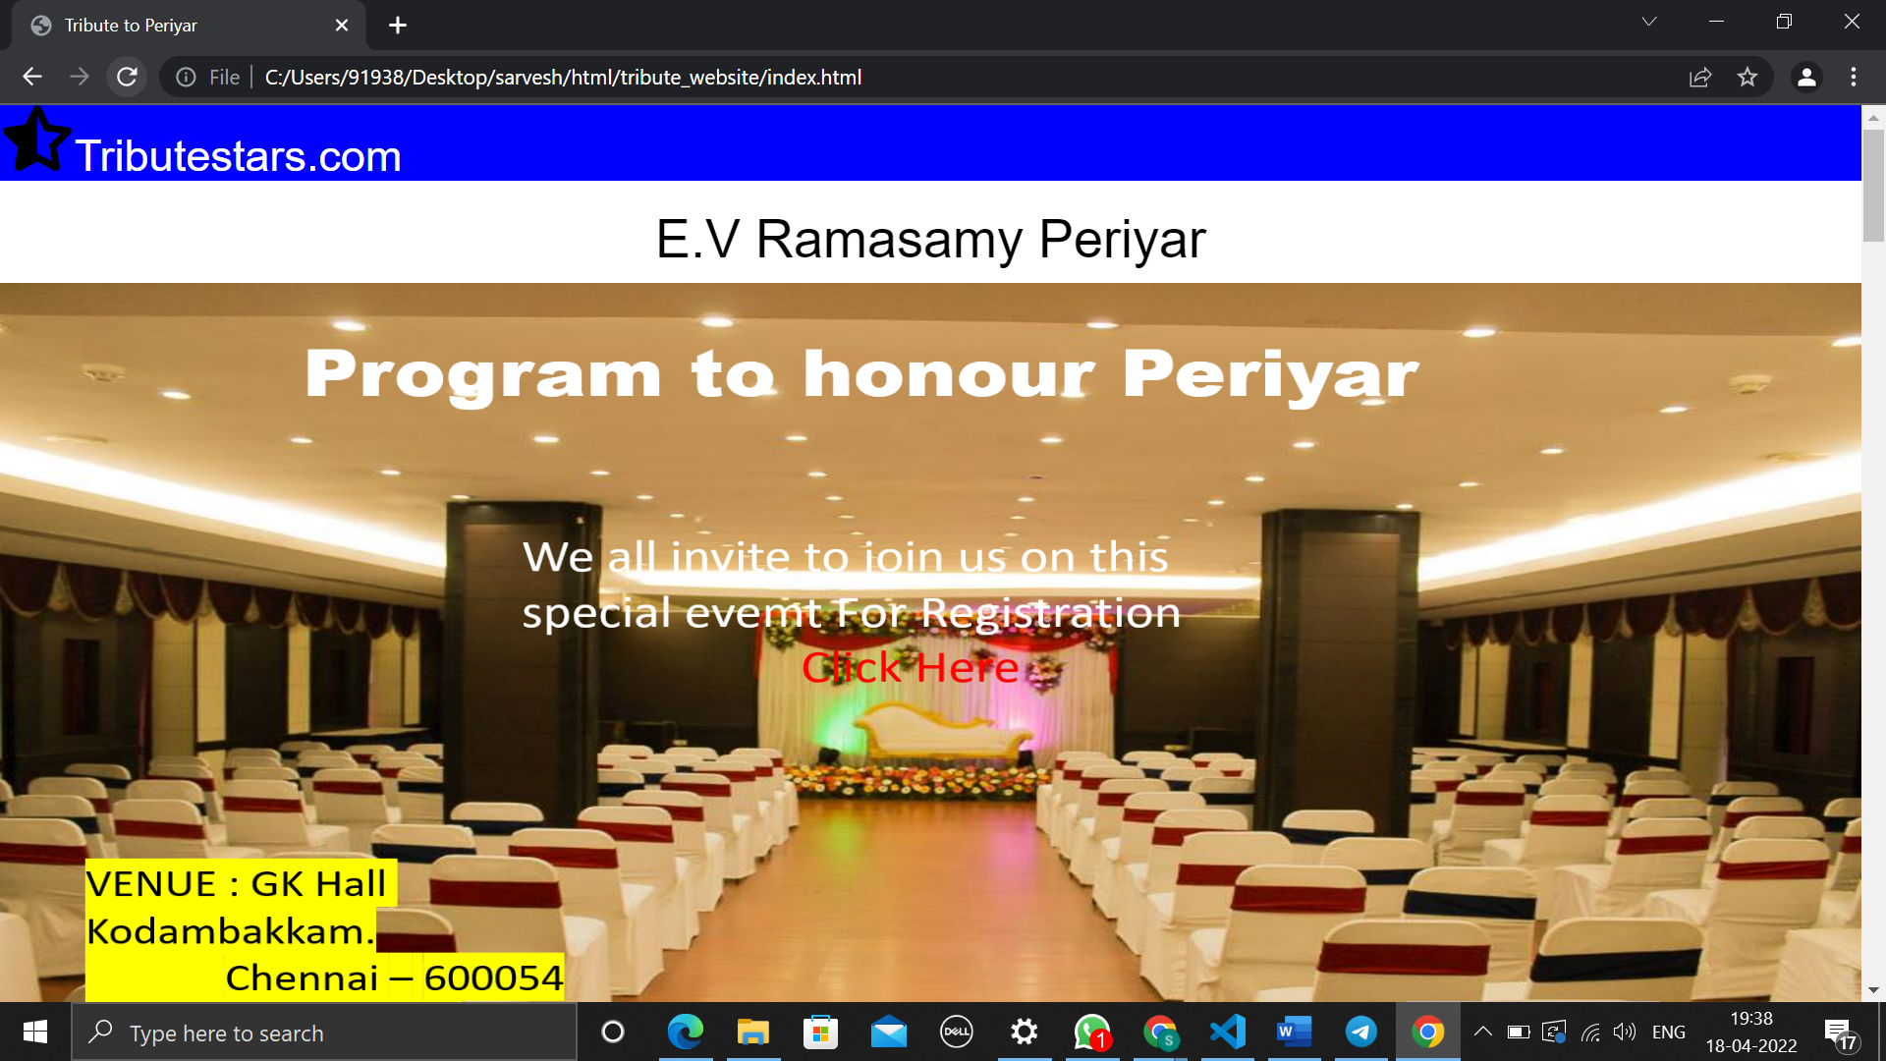 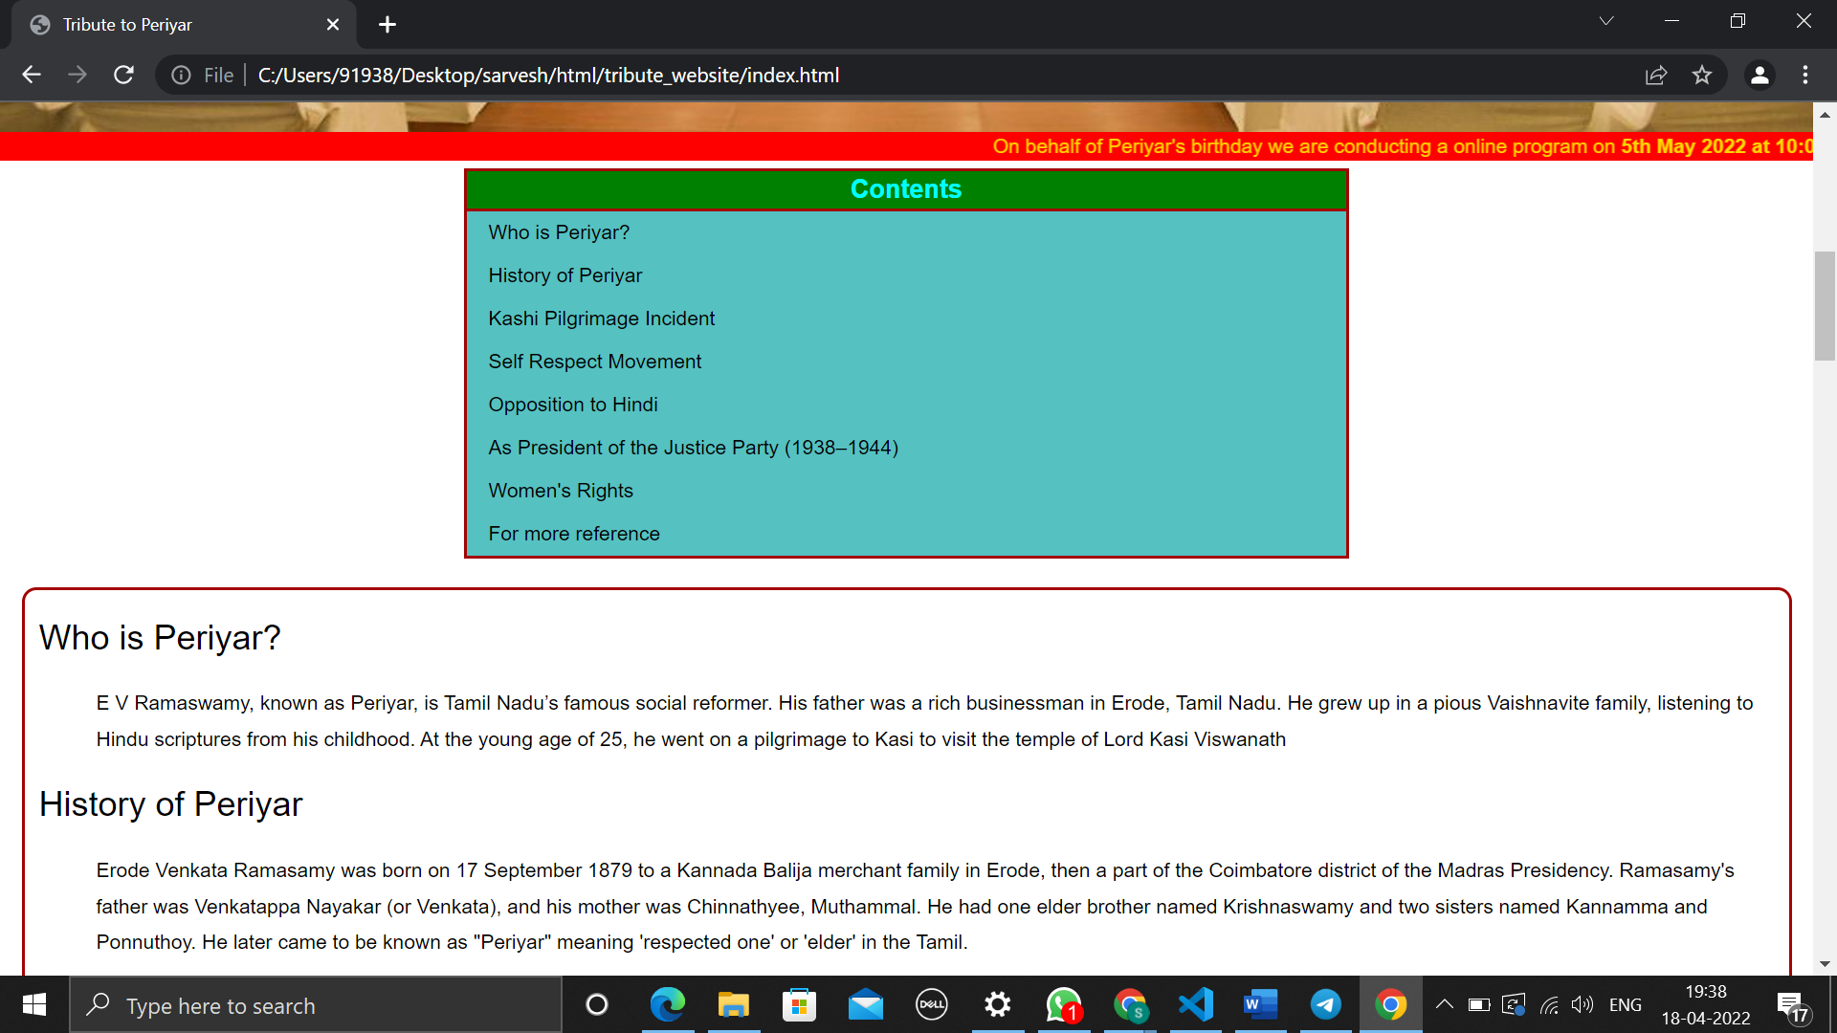 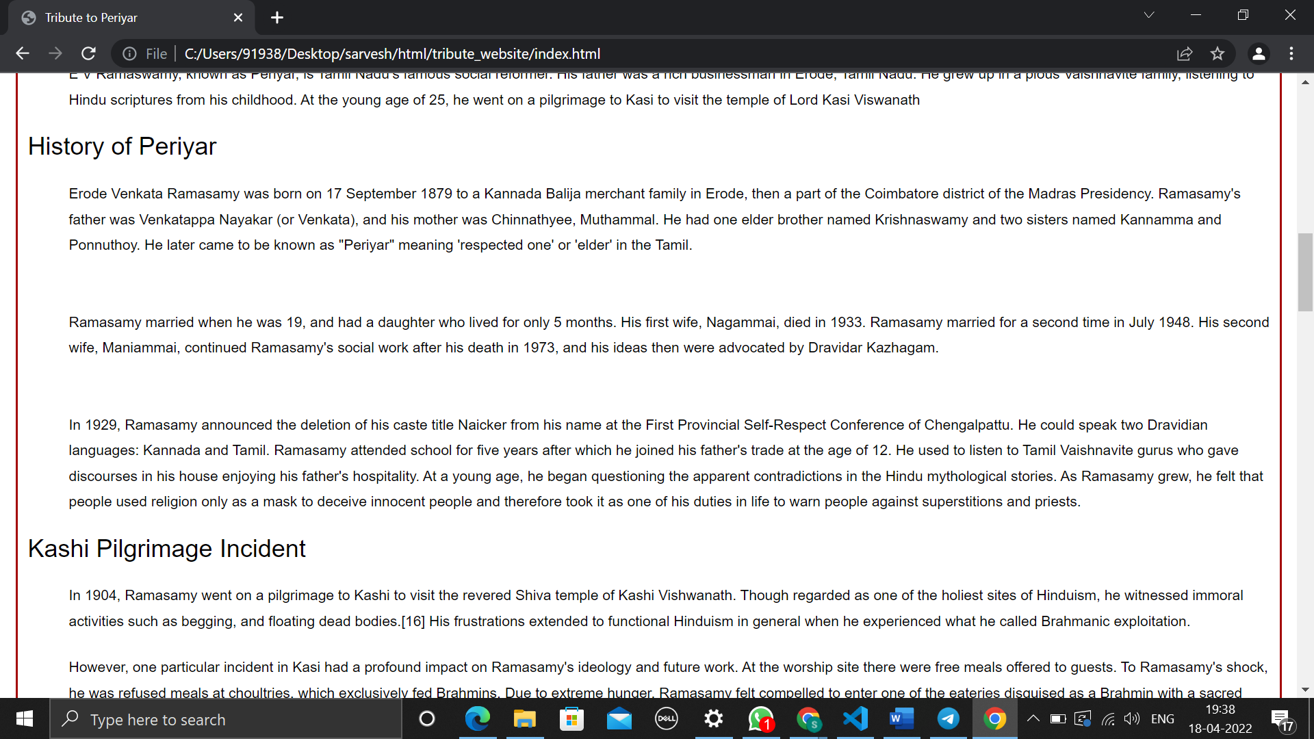 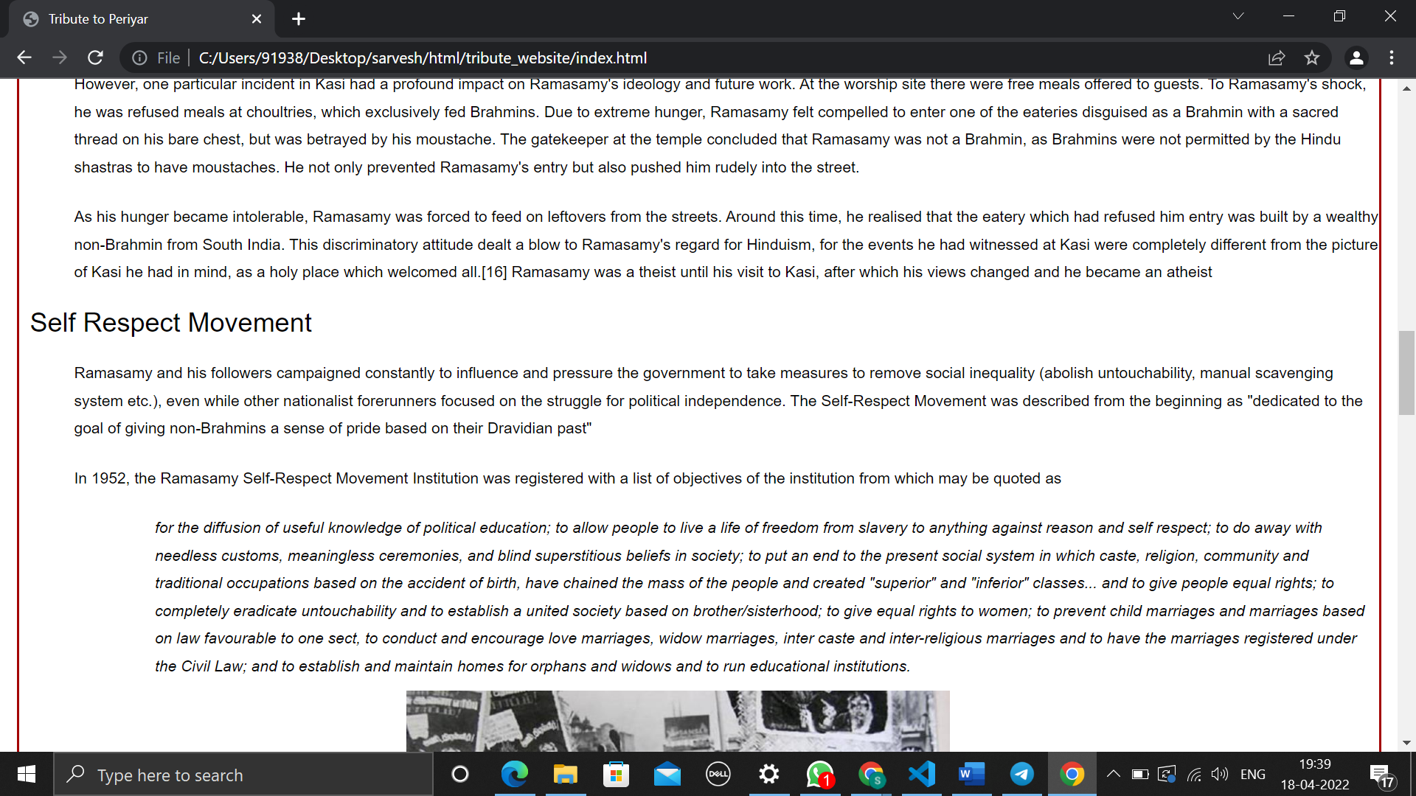 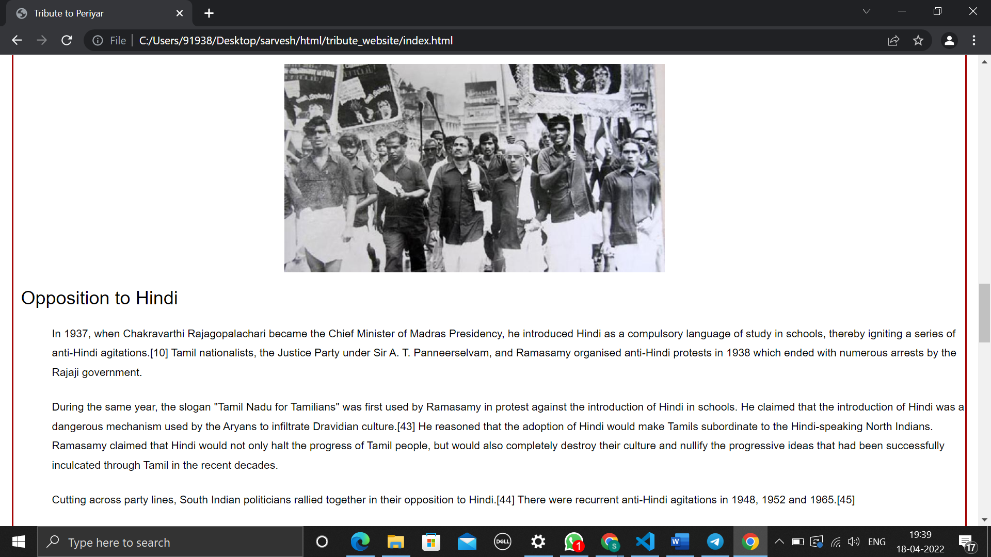 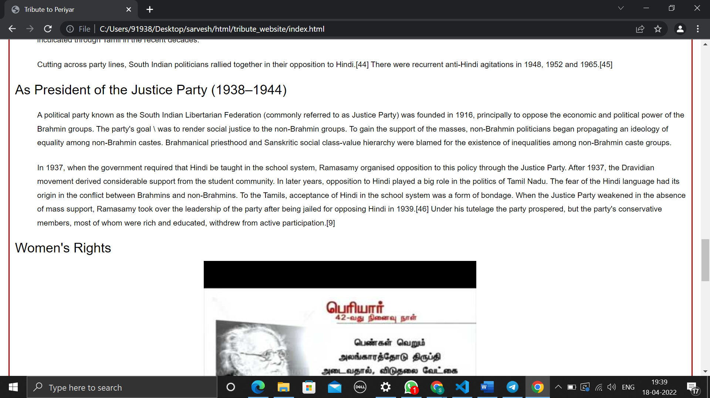 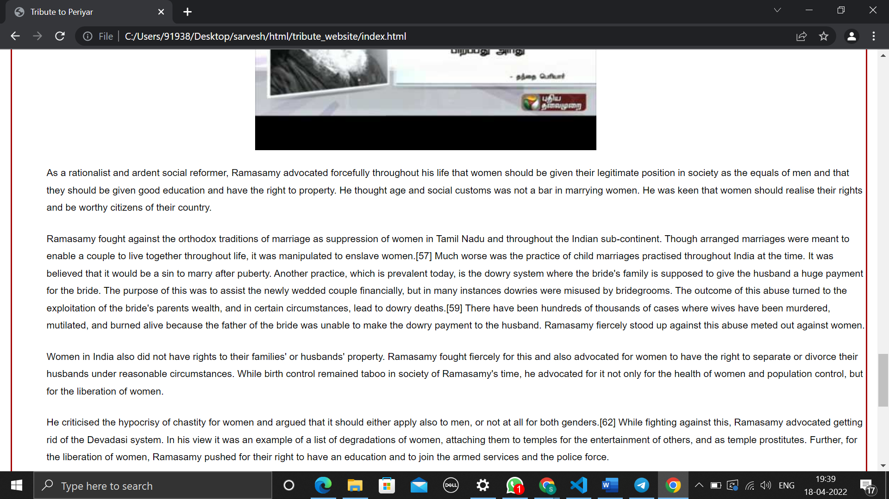 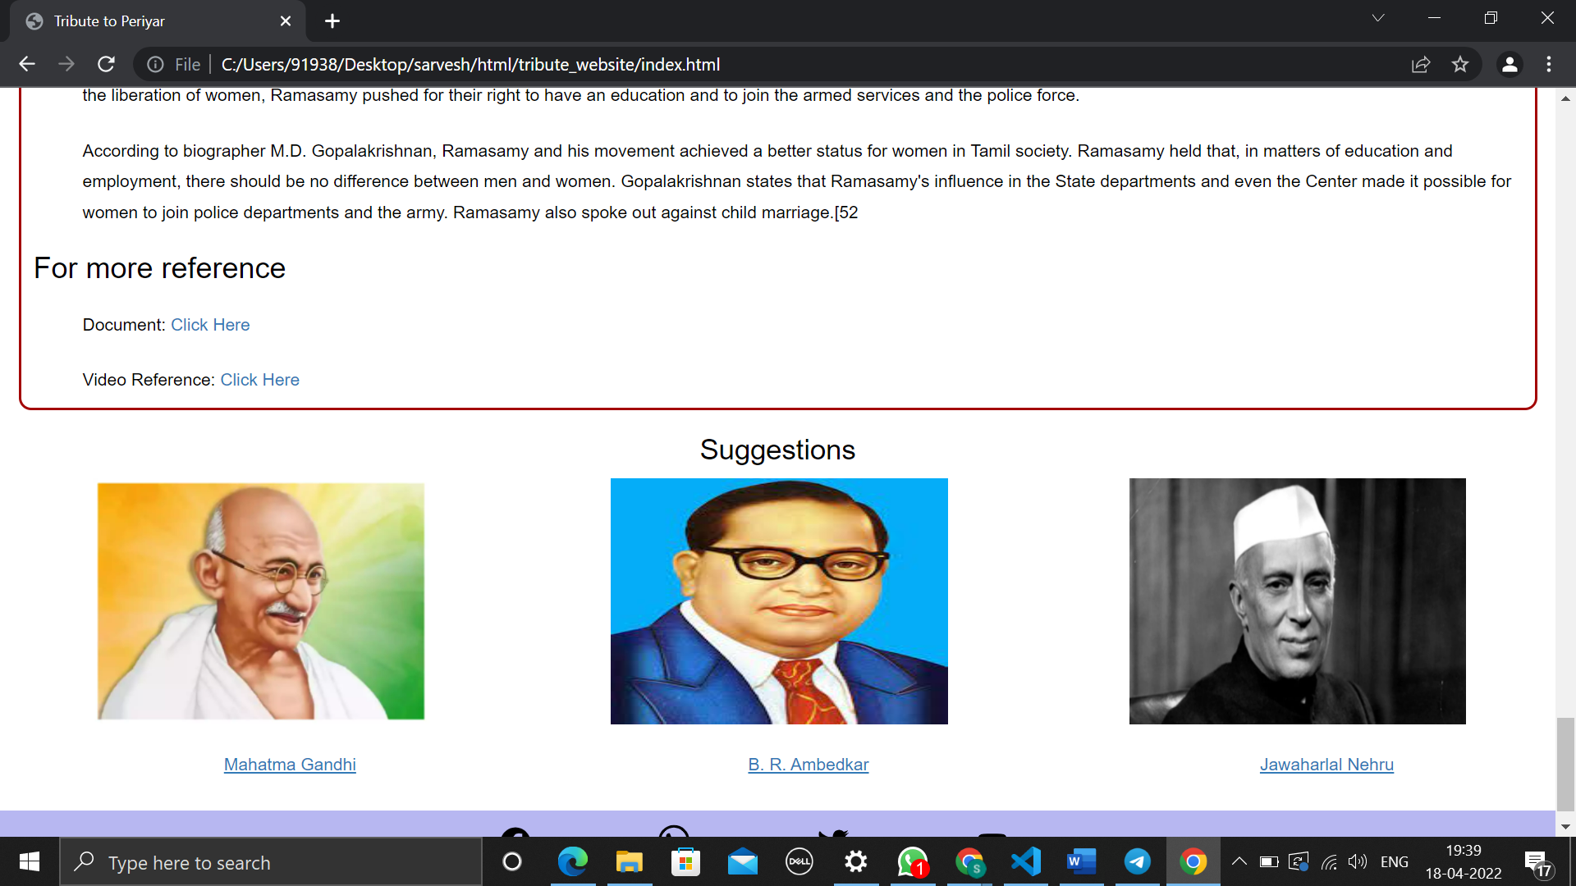 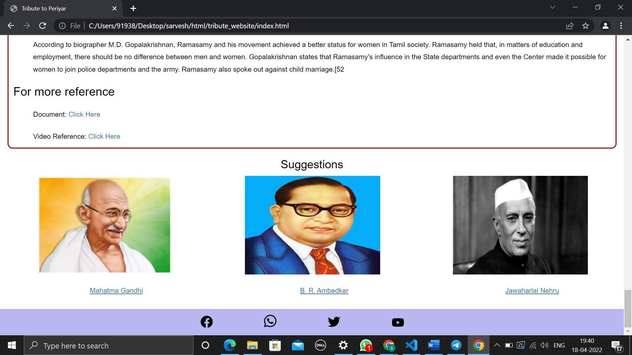

Form output

